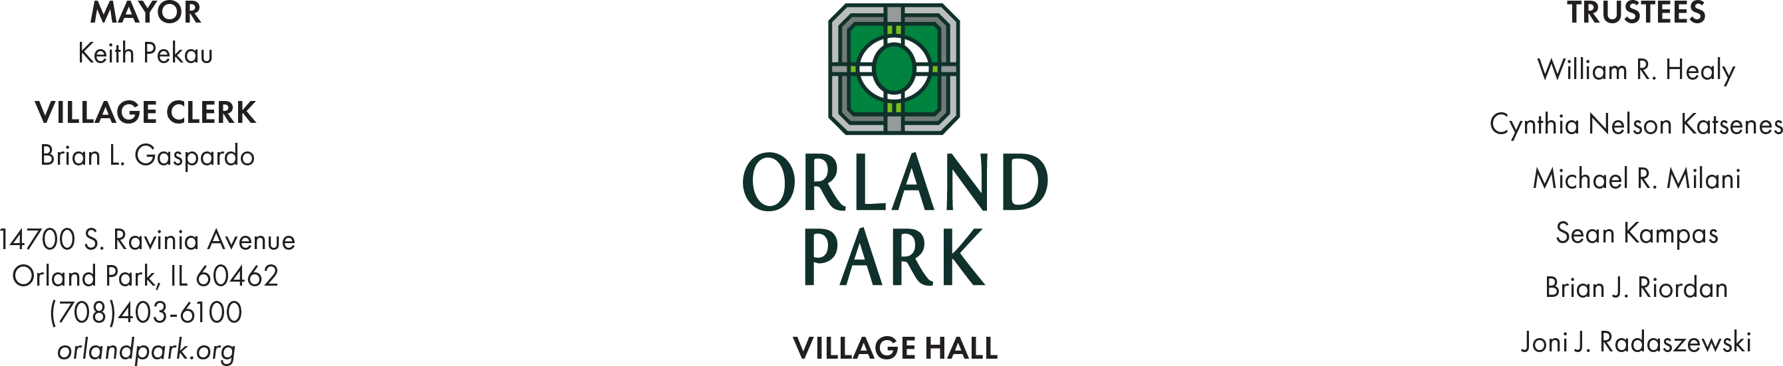

Village of Orland Park Proclamation
Honoring Darvin Furniture and Mattress
Business of the Month January 2025

Whereas, The Village of Orland Park is proud to recognize outstanding local businesses that contribute to the community's economic growth, diversity and vitality; and,

Whereas, Darvin Furniture and Mattress was opened by Louis Darvin after immigrating from Poland with his family in 1920. As Louis became a renowned furniture expert and as his customer base grew his son David became his business partner. In the 1960's Darvin quickly outgrew two locations and was adding on to their new location on Halstead Street in Chicago; and,

Whereas, during expansion in the 70's David's sons Steve and Marty joined the business becoming the third generation to own and run this successful business. A second location was opened in Matteson, IL and by 1980 they had planted roots in Orland Park. Over the 45 years Darvin has been located in Orland Park, they have gone through five expansions, making it Chicagoland's largest furniture store and a Top 100 furniture retailer in the nation; and,
Whereas, Darvin Furniture and Mattress has achieved impressive growth and success within its industry while maintaining its core values of integrity, customer focus, teamwork and innovation. The Village of Orland Park commends Darvin Furniture and Mattress on its dedication to their employees. Darvin made a major change in the Business structure in 2019, becoming a 100% employee-owned business. In August 2024 they held the first ESOP Vesting Ceremony and over 120 employees were recognized as 100% Vested.

Whereas, Darvin has worked closely with the Orland Park Mayor and local officials and has contributed generously to the betterment of the community through active involvement in local and nationwide charities, sponsorships and events demonstrating a commitment to making a positive impact far beyond their business operations; and,

Now, therefore, I, Keith Pekau, Village President of the Village of Orland Park, Illinois in the Counties of Cook and Will, do hereby extend the gratitude of the entire community to Darvin Furniture and Mattress for exceptional service to the community and hereby proclaim Monday, January 20, 2025 as Darvin Furniture and Mattress Day in the Village of Orland Park.

Signed: Dated: January 20, 2025 Keith Pekau, Village President
Village of Orland Park

